**Spike:** 7

**Title:** Graphs

**Author:** Parth Madhani ,101901858

**Goals / deliverables:**

* Code
* Spike Planning
  + Rough Design
    - Implementation of new classes
    - Template for world

**Technologies, Tools, and Resources used:**

* Visual Studio IDE
* tutorialspoint.com
* other web resources

**Tasks undertaken:**

* Research C++ Graphs
* Develop a plan to implement a graph in C++.
* Develop a plan to work out which new classes will need to be implemented to support loading the world from a file (World, WorldProcessor etc.).
* Research the different input methods available.
* Implement file design.

**What we found out:**

We found out how to make a basic graph data structure in C++ using a vector of lists with pairs which contains information about which nodes are joined to base parent node. This should make our navigation through the game world very simple mainly due to our list being list of pairs which helps us storing both the ID of the neighbour node, and the path description of how to get there (south, up, down, take shortcut, etc.).In terms of design, after some research I opted for a file format which follows a similar convention as that of XML. This makes it very easy to parse the file and expand if necessary.

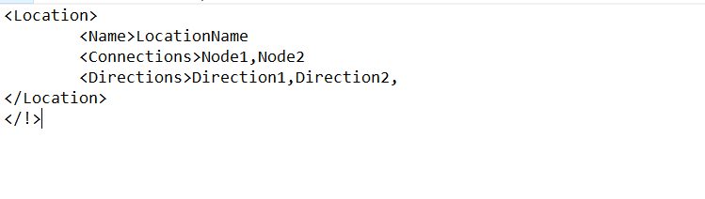

Fig 1. Basic file design